 **College of Engineering**

Carnegie Mellon University

5000 Forbes Ave.

Pittsburgh, PA 15213

[www.engineering.cmu.edu](http://www.engineering.cmu.edu)

**Contact:** Tara Moore For immediate release:

412-268-9673 May 3, 2016

[tararaemoore@cmu.edu](mailto:tararaemoore@cmu.edu)

**Lithium Market Fluctuations Unlikely to Significantly Impact Battery Prices**

PITTSBURGH—Global lithium prices have more than doubled over the last six months as battery producers scramble to secure purchasing rights from an increasingly consolidated number of lithium producers, who find themselves able to demand premium pricing as a result of a delay in bringing more lithium production capabilities online. This could be particularly concerning for the manufacturers of lithium-ion cells for electric vehicles. To address this, a new Carnegie Mellon University College of Engineering study has found that even large increases in lithium prices are unlikely to significantly increase the cost of batteries or battery packs for end users such as vehicle manufactures or consumers, though some manufacturers may see reduced profit margins.  
 The Carnegie Mellon University team, whose study was published in the *Journal of Power Sources*, analyzed multiple lithium-ion battery chemistries and cell formats to see whether extreme lithium price variations would have a substantial impact. They examined the impact on cell costs if lithium prices increased to $25/kg, more than four times the historical average, and found that lithium is a relatively small contributor to both the battery mass and manufacturing cost.  
 “Although the battery cost increases were the largest for high power-density cells, which require a lot of material inputs, cell costs never increased more than 10% even using the most extreme assumptions,” says Rebecca Ciez, an engineering and public policy Ph.D. student.  
 While this is not a large percentage of total costs, it could be significant for lithium-ion battery manufacturers, like those who manufacture batteries for electric vehicles and operate on slim or negative profit margins.  
 The paper also addresses a secondary issue: some investors urge researchers to come up with alternatives to lithium due to shortages.  
 “Lithium is plentiful, and our current sources are not the only sources of lithium—they are merely the cheapest. If prices do quadruple, it becomes, in principle, economical to extract lithium from sea water,” says Jay Whitacre, professor of materials science engineering and of engineering and public policy.  
 For battery manufacturers concerned about the long-term future of lithium-ion batteries, Whitacre says, “There are many other reasons to pursue different battery chemistries, but access to lithium resources is not one of them.”  
 This work was supported by a National Science Foundation Graduate Research Fellowship.  
 Read the full 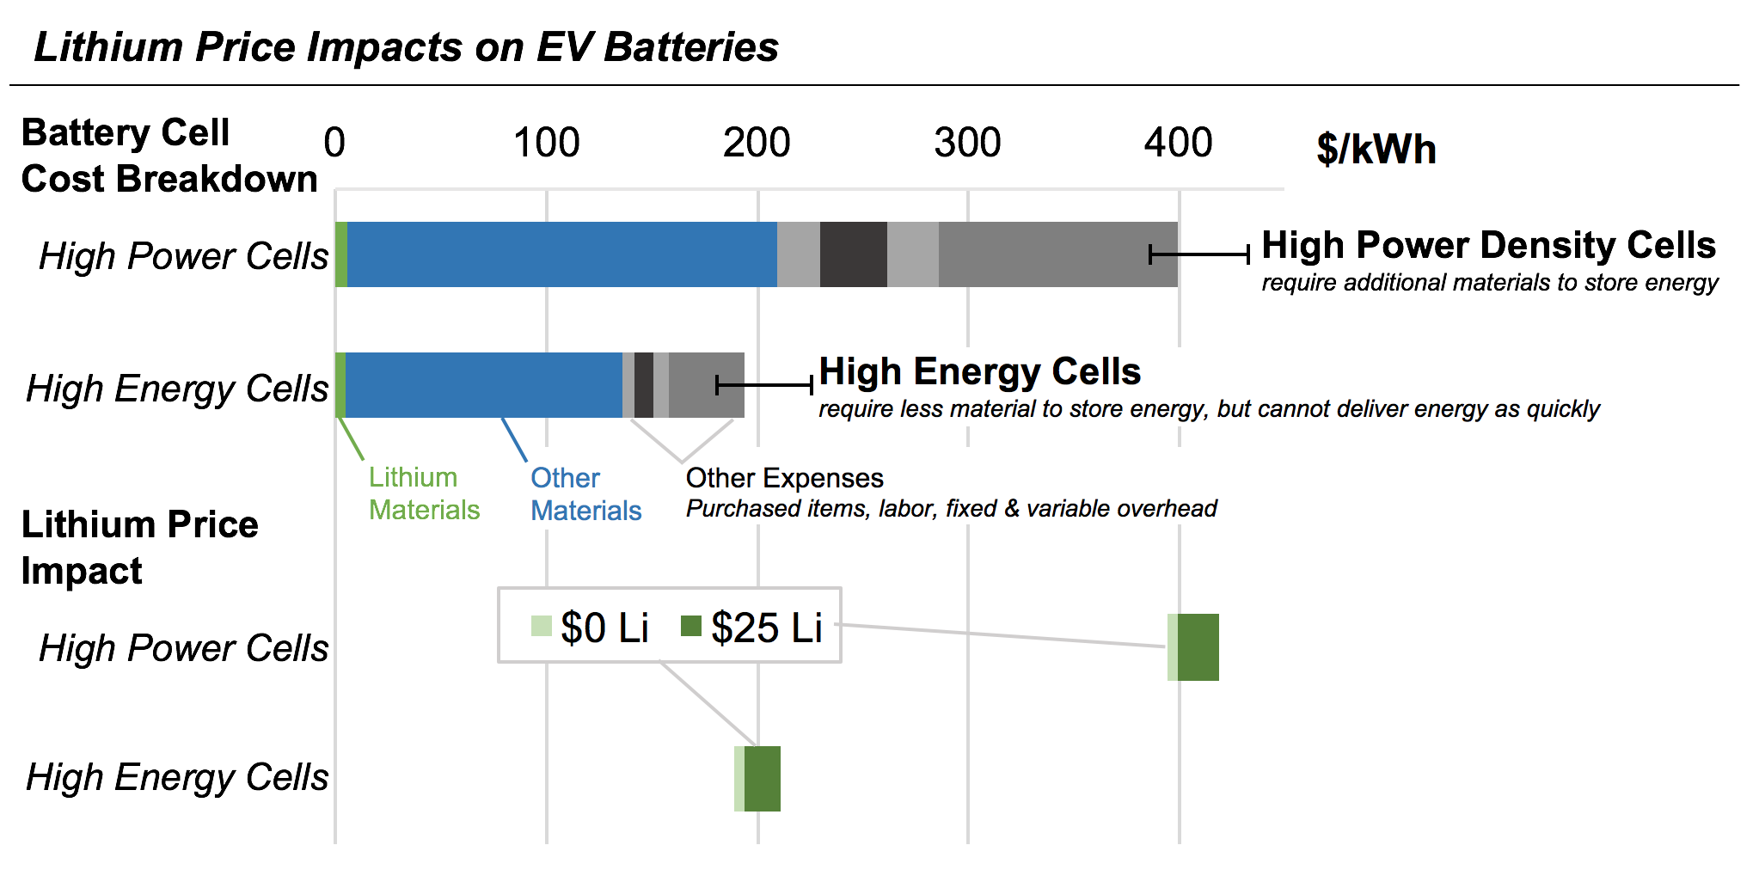paper: <http://www.sciencedirect.com/science/article/pii/S0378775316304360>

###

**About the College of Engineering:** The College of Engineering at Carnegie Mellon University is a top-ranked engineering college that is known for our intentional focus on cross-disciplinary collaboration in research. The College is well-known for working on problems of both scientific and practical importance. Our “maker” culture is ingrained in all that we do, leading to novel approaches and transformative results. Our acclaimed faculty have a focus on innovation management and engineering to yield transformative results that will drive the intellectual and economic vitality of our community, nation and world.

**About Carnegie Mellon University:** Carnegie Mellon ([www.cmu.edu](http://www.cmu.edu/)) is a private, internationally ranked university with programs in areas ranging from science, technology and business to public policy, the humanities and the arts. More than 13,000 students in the university’s seven schools and colleges benefit from a small faculty-to-student ratio and an education characterized by its focus on creating and implementing solutions for real world problems, interdisciplinary collaboration and innovation.